

INTERNSHIP SUCCESS
Face Recognition Clock-In System Overview and Testing Day 1
Date : 04 December 2025

SYSTEM OVERVIEW AND OBJECTIVES

- Problem statement
- The solution
- Our competitors and research based facts
- Testing
- ADMIN
- Creation of host company’s profiles and departments
- Creation of interns in host companies
- Generating interns and host company’s clock-in data and time sheet report
- Delete and edit interns and host companies
- HOST COMPANIES
- Can mentor login?
- Can mentor add, view, edit and delete interns in their company?
- Can mentor add a department and add an intern inside that department?
- INTERN/ STAFF
- Can an intern/staff clock-in, start lunch and end lunch?
- Can intern/staff clock-in outside their assigned location?
- Can intern clock-in using somebody’s device?
- Can intern /staff spoof the system?

- Suggestions

- What is the problem?

- Companies and Schools face challenges with Tradition Attendance management systems

- Manual Systems (Hard Copy Attendance Register)
- Human errors
- Inaccurate attendance records
- Card-Based Systems
          - Staff / interns can share, get stolen or loss
- Basic Biometric Systems
- Easy to spoof / Bypass with images

THEIR NAGATIVE IMPACT!
* No location validation – Users may clock-in anywhere since no physical tracking
* Inefficient management and poor decision making
* Incorrect payroll and Hardware costs

OUR SOLUTION

      - Internship Success Clock-In System: Enterprise-Grade, AI-Powered Attendance Management!
- complete, secure, and cost-effective attendance management system that solves ALL these problems

  - HOW??

- BANK-GRADE FACE DETECTION AND SECURITY SYTEM!
- 99.83% accuracy (AI industry-leading ArcFace and ONNX runtime models)
- Impossible to share or fake
2. GPS LOCATION VERIFICATION
- Real-time location validation
- 5km radius for town-level locations
- Prevents remote clock-in fraud
3. DEVICE FINGERPRINTING
- Unique device identification
- Trusted device management
- Detects suspicious device switching
- To prevent unathorized devices ( IoT devices)

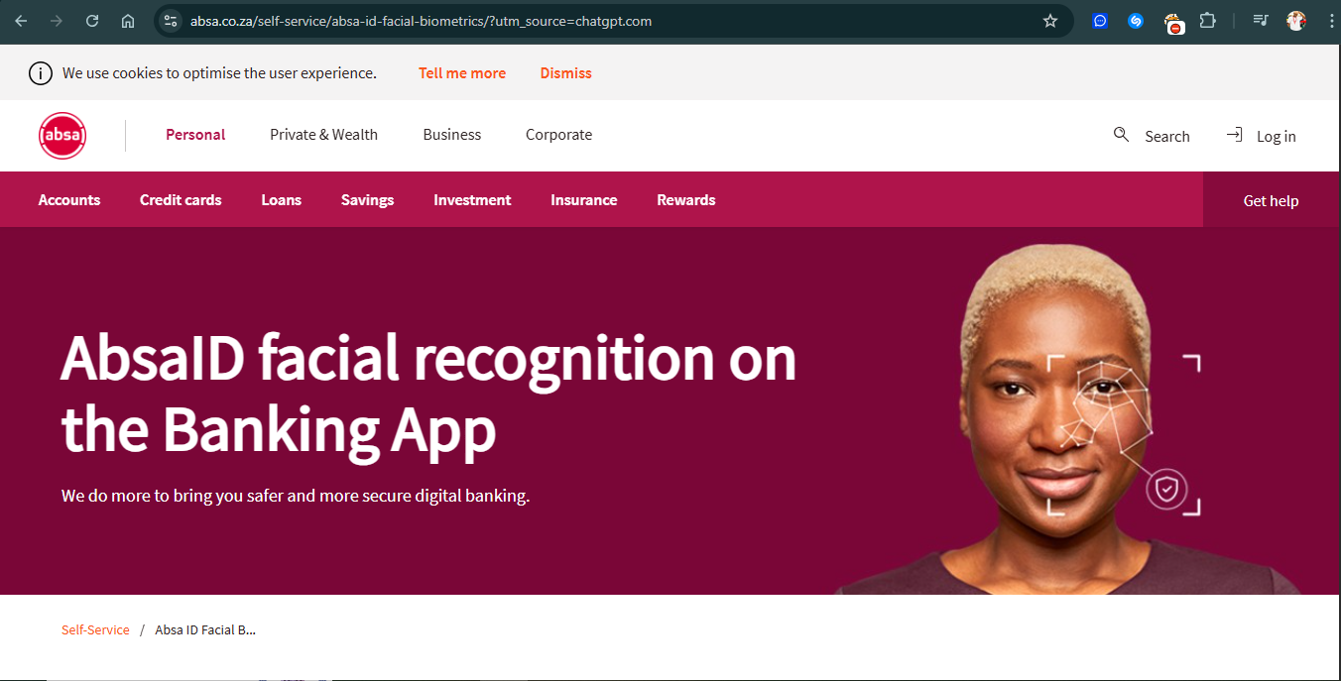
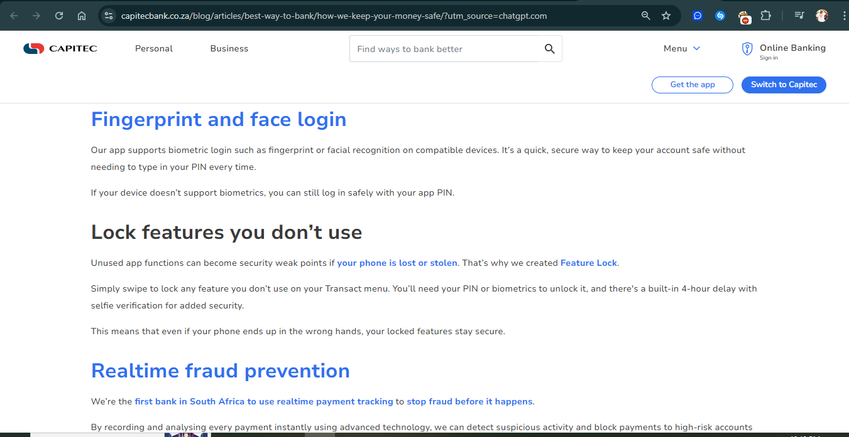
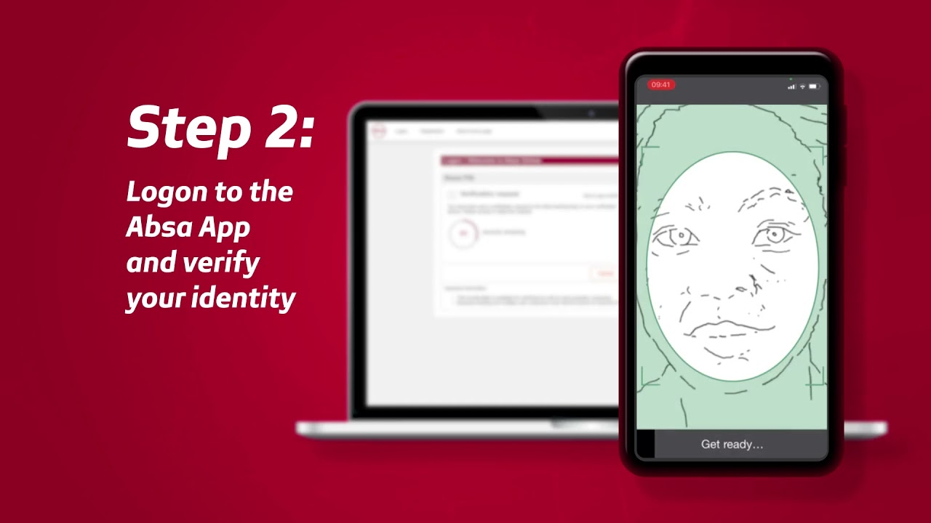
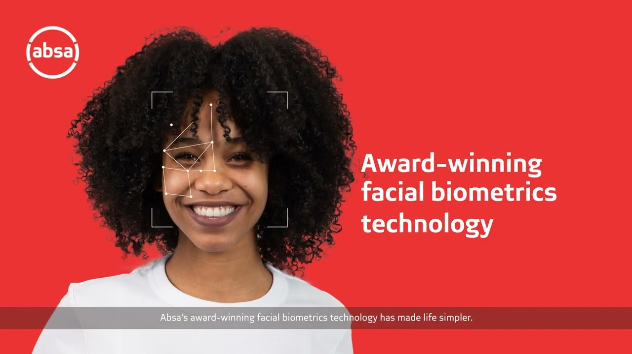

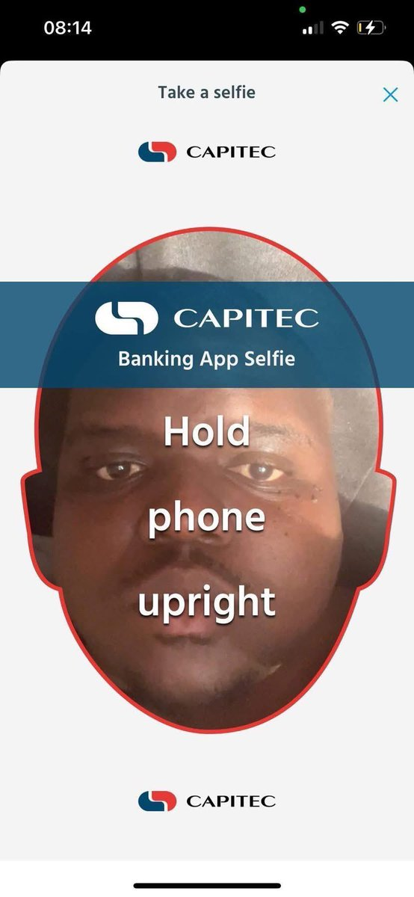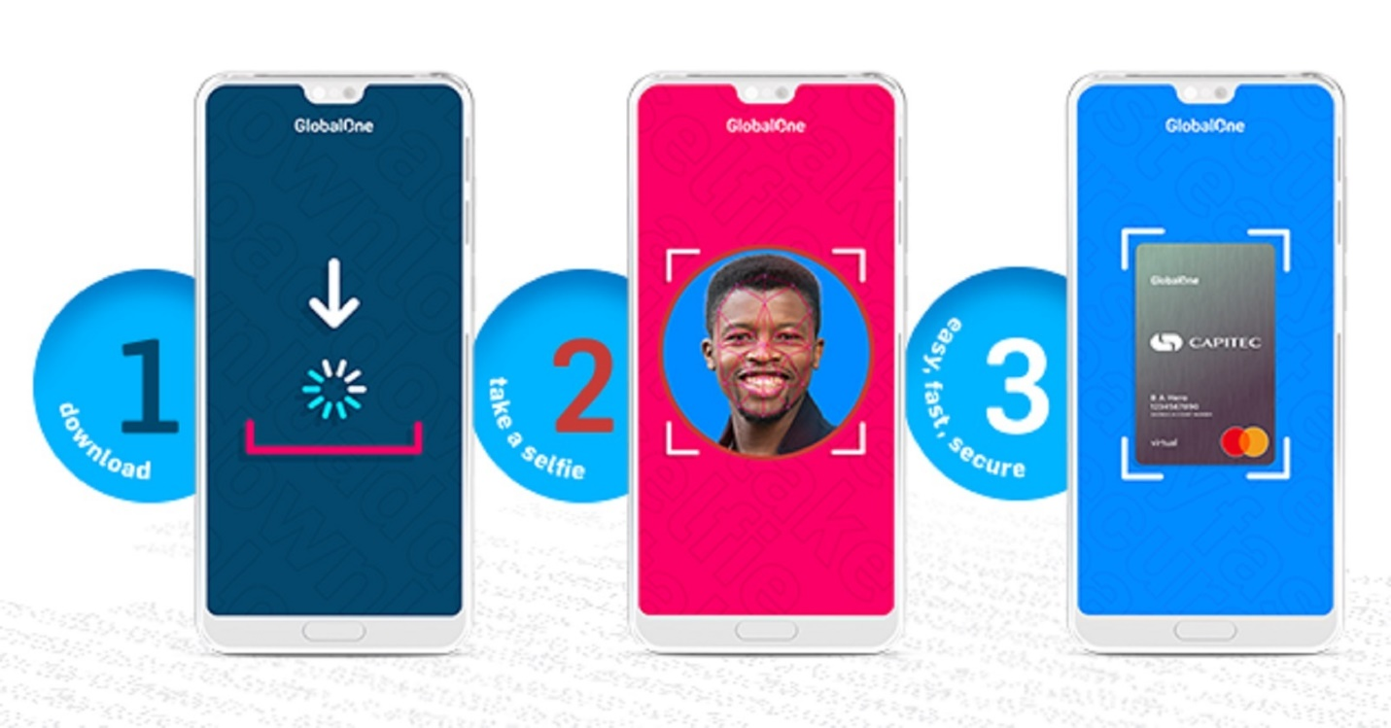

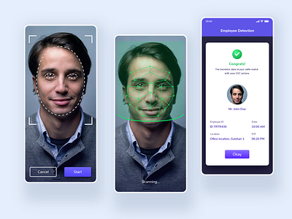

OUR COMPETITORS

- EduTrack Attendence Management System

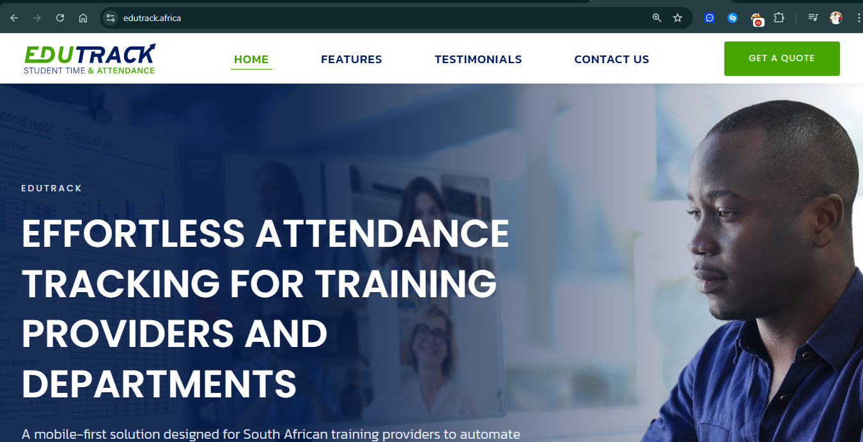
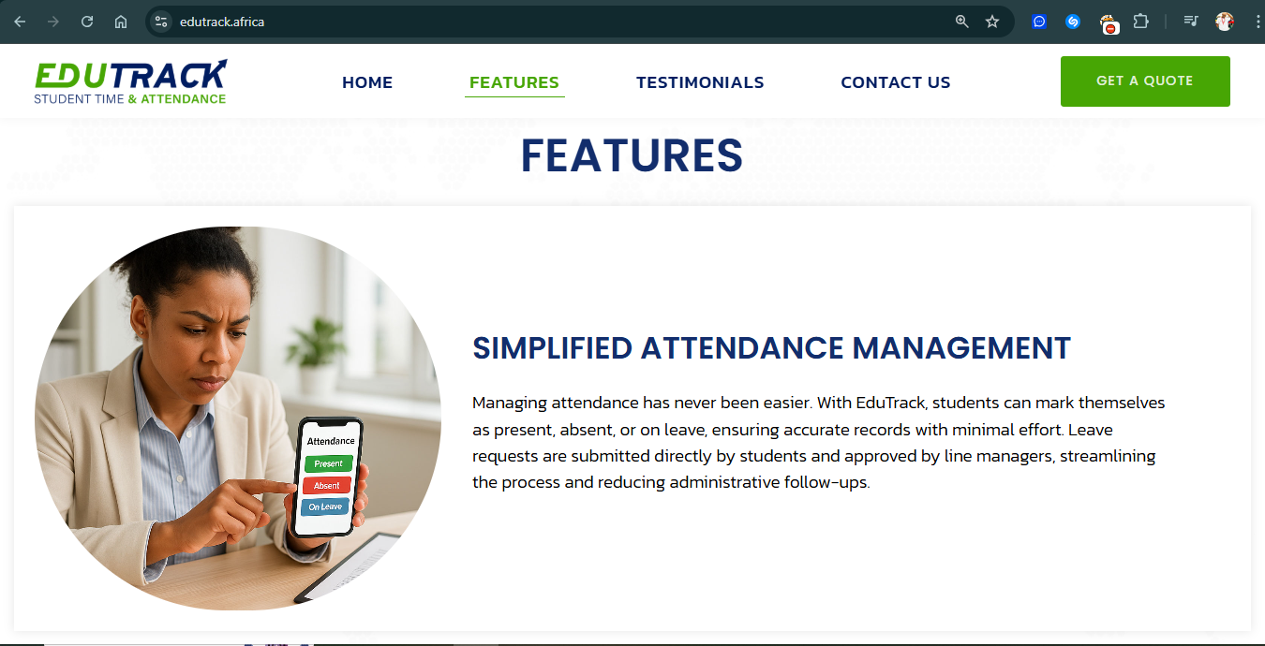

Website? Lets see
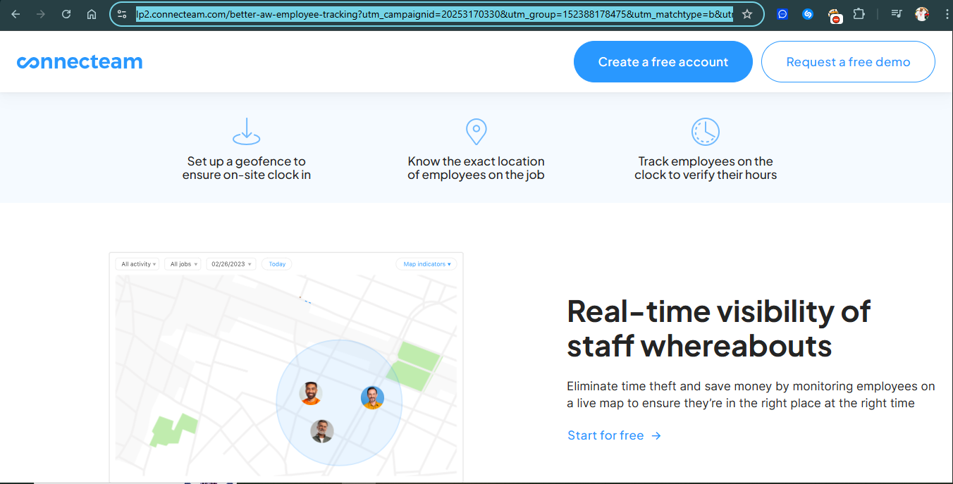

Website? lets see!

- MY AT
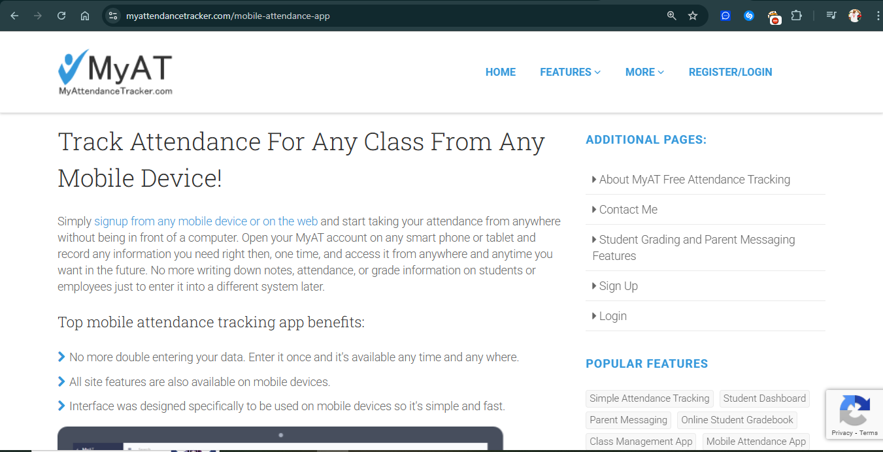

Website? lets see!!
LETS TEST AND SEE HOW BEST AND UNIQUE OUR SYSTEM IS FROM OUR COMPETITORS!

